Culinary Arts and Foodservice Management Training

An Overview of Florida Tomatoes in Foodservice

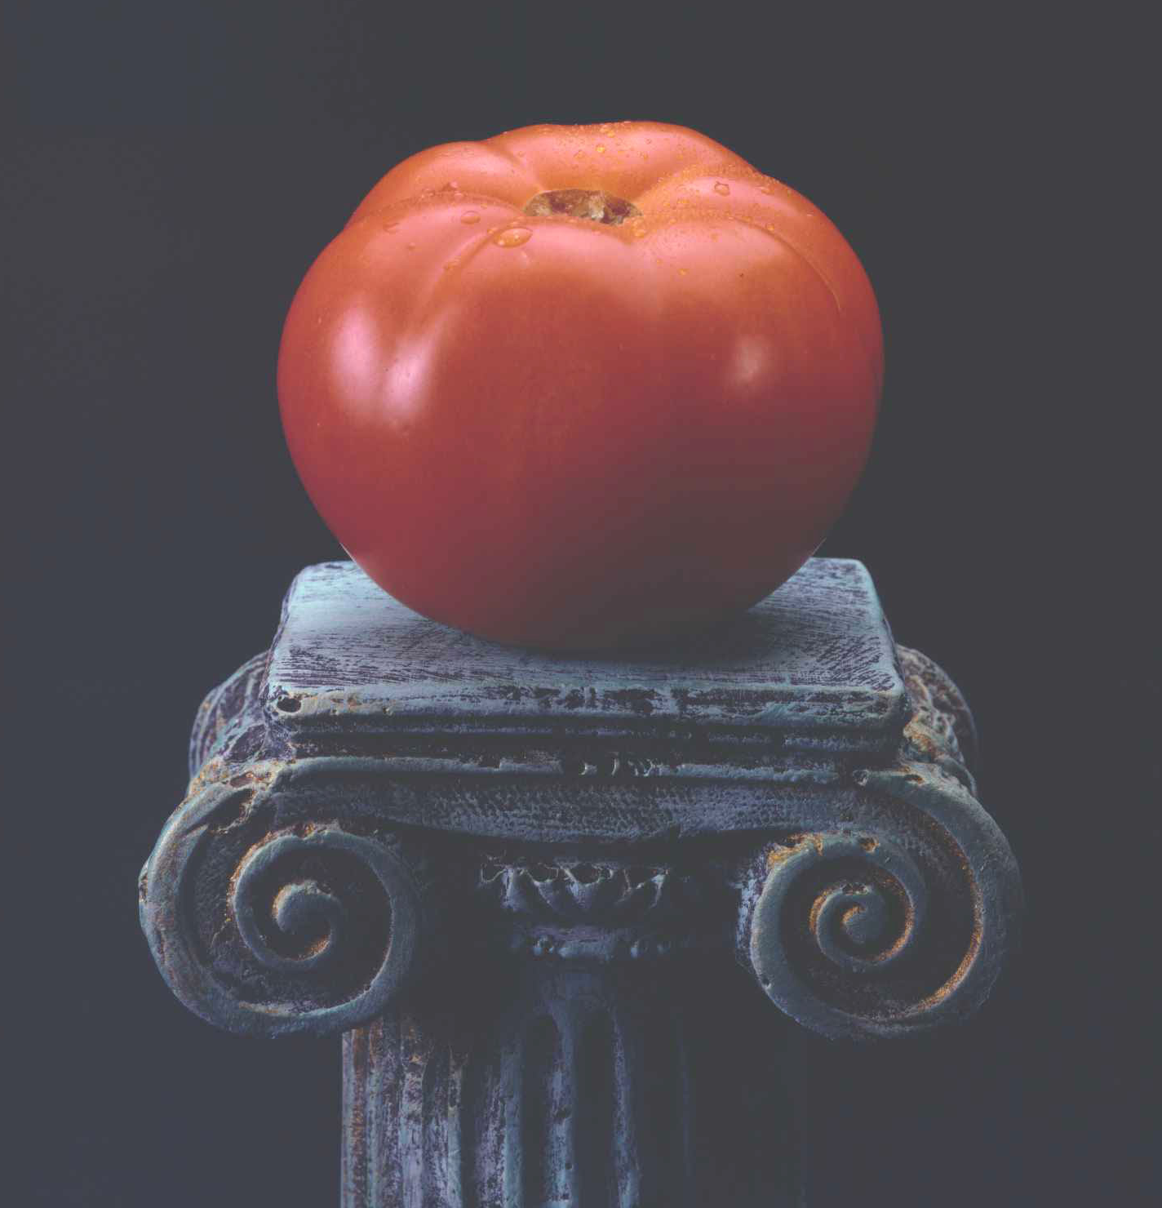

Ronald S. Wolf, BS, MA
Professor, Culinary Arts, Florida Community College at Jacksonville

Curriculum Objectives

- Demonstrate appropriate handling, storage and preparation techniques for Florida field-grown tomatoes

- Describe ways to maximize flavor, texture and yield when working with Florida tomatoes

- Describe the handling and ripening for Florida tomatoes

- Show how to prepare a variety of innovative foodservice recipes utilizing Florida tomatoes reflecting both regional styles as well as contemporary ethnic cuisines

- Highlight various cooking methods for utilizing Florida tomatoes including roasting, broiling and pan frying

- Describe key health benefits associated with including Florida tomatoes in the diet as well as ongoing research

- Show the key areas where Florida tomatoes grow, and how they are harvested and packed

- Discuss culinary trends as they relate to the use of Florida tomatoes

- Demonstrate how increased menu usage of Florida tomatoes can increase profitability

Introduction
Today’s dynamic foodservice industry demands trained, dedicated culinary professionals. This resource has been created to assist in developing or augmenting existing training programs related to produce, and specifically, Florida field-grown tomatoes. Areas covered include basic foods, purchasing and receiving, nutrition, menu planning, regional and international cuisines. The following table suggests ways to connect this varied information on a culinary staple into existing training.

Section Areas Covered
PART I | History, Cultivation and Harvesting
PART II | Purchasing, Receiving, Ripening & Storage
PART III | Prep, Cooking Methods and Recipe Applications
PART IV | Tomato Preferences
PART V | Nutrition and Research
PART VI | Environmental &Food Safety Issues

PART I
HISTORY, CULTIVATION AND HARVESTING

Brief History of the Tomato
The tomato, native to the Americas, has made its mark on cuisines around the world. The conquistadors encountered tomatoes, called xitomatl by Aztecs, when they arrived in the New World. They carried their discovery back to Spain, where the name became tomate. From there, tomatoes made their way to the rest of Europe. Temperate regions along the Mediterranean were particularly conducive to growing the sun-loving fruit.

Around the Mediterranean, the tomato found its way into Spanish gazpachos, French salads, Italian sauces, North African tagines, and, eventually, Indian curries and other Asian dishes.

The Spanish and the Italians hailed the tomato as an aphrodisiac (perhaps because of its resemblance to the human heart) when it arrived from the New World during the 16th century. But even though tomatoes soon became part of Spanish and Italian cuisines, many other cultures thought tomatoes to be poisonous. Consequently, their acclimation into English and Colonial cuisine followed centuries later.

While botanically the tomato is a fruit on the vine, in the kitchen, it is almost always treated as a vegetable. In fact, in 1893, the United States Supreme Court ruled, for the purpose of levying a tariff, that the tomato was a vegetable because of its culinary usage. In today’s professional kitchen tomatoes are used in many traditional and contemporary dishes paired with flavors of all regional and world cuisines. The tomato also contributes to overall menu profitability given its popularity, reasonable food cost, ease in preparation and outstanding yield.

Where Florida Tomatoes Grow
Like the sunny Mediterranean region, Florida has the warm temperatures necessary for cultivating tomatoes for much of the year. The state’s tomato industry is believed to have started in the 1870’s. Today, Florida is the nation’s largest producer of fresh tomatoes. Almost every county in the state grows tomatoes, and Florida produces virtually all the fresh-market, field-grown tomatoes in the U.S. from October through June. The harvest moves from north Florida in the fall to Homestead, south of Miami in the winter, then back north through the spring, with some regions having two seasons each year. Regions with the greatest production are districts 3 and 4 (see State Production Map) in the southwestern half of Florida.

Growing, Harvesting and Packing
Tomato plants are started in greenhouses, and the seedlings are transplanted to fields about five weeks later. One pound of seed produces up to 140,000 tomato plants. As they grow, nearly all the tomato plants are supported by stakes. This greatly increases production costs, but improves yields and the overall quality of the fruit. In Florida, tomatoes are entirely harvested by hand roughly 100 to 120 days after the seeds are planted. At the mature green stage, when typically picked, they have reached their full size and contain virtually all of the vitamins and nutrients of fully ripened tomatoes. Following a warm chlorinated bath and rinse, the tomatoes are graded by size and color and shipped to market.

Facts and Figures
- Approximately 39,000 acres were under cultivation for the fresh tomato market in 2006-07

- Florida ships more than 1.3 billion pounds of fresh tomatoes to the U.S., Canada and abroad

- About 33,000 workers are needed to hand pick the fruit

- Total crop value at the farm level exceeds $403 million

- The cost of producing and harvesting tomatoes averages more than $11,600 per acre

- Tomatoes comprise nearly one-third value of all fresh vegetables produced in Florida each year

PART II
PURCHASING, RECEIVING, RIPENING AND STORAGE

Purchasing and Receiving Considerations
Florida tomatoes are packed in 10, 20 and 25-pound boxes, but the 25-pound box is by far the most common size ordered in foodservice. The quantity of tomatoes found in a box will vary depending on the size of the tomatoes. Upon arrival at your establishment, mark the date on the carton. Be sure to rotate stock, first in, first out, or FIFO. You should discuss with your purveyor the stage or ripeness the tomatoes will arrive, and how they will be held prior to delivery. For proper ripening, fresh tomatoes should never be held at a temperature below 55º F. If possible, upon delivery, check the pulp temperature of samples to verify transport temperatures were above 55º F. A 25-pound box of tomatoes may contain the following:

- 5x6 (formerly extra large tomatoes) about 38-62 tomatoes
- 6x6 (formerly large tomatoes) about 62-80 tomatoes
- 6x7 (formerly medium tomatoes) about 87-115 tomatoes

Tomatoes can also be ordered “Place Pack” which is 18 to 20-pound boxes in which the tomatoes are hand packed in rows.

Size & Yield Tips
Use the following size and yield approximations to assist in ordering tomatoes.

- 1 large tomato weighs about 8 ounces
- 1 medium tomato weighs about 5 to 6 ounces
- 1 pound of tomatoes yields about:
- 2 to 2-1/2 cups chopped
- 3 cups wedged or sliced
- 1-1/2 cups pureed

Quality Standards
Each field-grown tomato shipped out of Florida is regulated by a Federal Marketing Order that controls grade, size, quality and maturity. The standards are the toughest in the world and ensure that Florida tomatoes are the best you can buy. Further, they’re grown under stringent government food safety regulations established by the Environmental Protection Agency and the US Food and Drug Administration and enforced by the Florida Department of Agriculture and Consumer Services.

Receiving and Ripening
When you receive Florida field-grown tomatoes do not refrigerate them. This storage rule holds true whether your tomatoes arrive from the supplier already ripened and ready for use, or you plan on additional ripening at your operation.

A tomato whose temperature drops below 54.5º F (12.5º C) will not finish ripening as cold halts the ripening process. Since cold also kills the flavor of tomatoes, even when the tomatoes are fully ripe, keep them out of cold storage. If you must keep tomatoes in a cooler, wrap them in a thermal blanket and place them near the door. Tomatoes are best held in a dry storage area (see below for ideal conditions for a non-refrigerated, dry storage area appropriate for tomatoes), but can also ripen well in any dry, room temperature area, such as under or above work tables or on a baker’s rack, because they can be spread out on trays in a single layer and easily checked for progress. Determining how long to ripen tomatoes depends on the condition that they arrived in your kitchen. Typically, a day or two may be enough, and usually no more than five. A good rule of thumb is to have some on hand at different stages of ripeness, so there is a steady supply when needed.

Always store your tomatoes stem end up. The stem end, where it was separated from the vine, is the most delicate part of the tomato. Florida tomatoes are shipped without their stems, to protect the fruit. Leaving tomatoes on their shoulders, even for a few days, is enough to bruise them, and once bruises appear, spoilage will eventually follow.

To prevent being crushed during shipping, Florida tomatoes often arrive at the pink (see below) stage and will likely require some additional ripening to bring out their full red and juicy nature. Just like any other fruit (think green bananas) they must be ripe to be fully enjoyed. You can either ripen Florida tomatoes in your establishment or work with your vendor who can provide you with product that is fully ripened and ready to use. You can expect to pay a premium for fully ripe tomatoes, and the cost must be balanced against space and time considerations. In order to better understand the ripening process, the six ripening stages, from green to fully ripe, are described below:
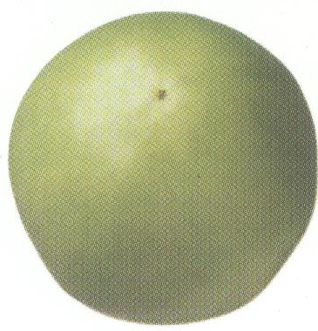
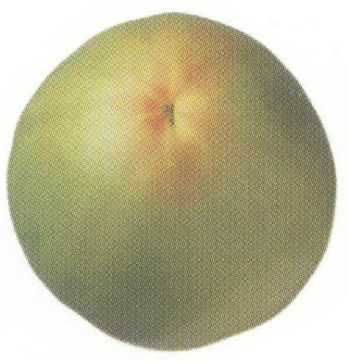
Stage 1 Green: The tomato surface is completely green. The shade of green may vary from very light to dark. This is the ideal stage for preparing Fried Green Tomatoes, a southern favorite that involves coating seasoned, sliced tomatoes with corn meal, and shallow or pan frying. Tomatoes in this stage must be specified when ordering.

Stage 2 Breakers: There is a definite break of color from green to yellow, pink or red on 10% or less of the tomato surface. Tomatoes are typically shipped at this or the following stage.
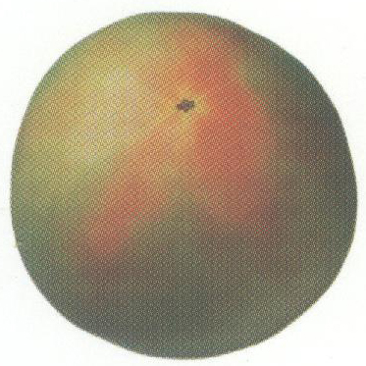
Stage 3 Turning: Yellow, pink and/or red color shows on over 10%, but no more than 30% of the tomato surface.

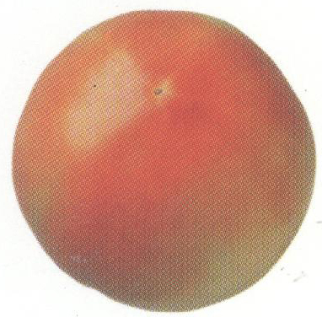
Depending on your purveyor, you may receive fresh, field-grown tomatoes at any of the following stages. With proper handling (never falling below 55º F) and timely usage, you will maximize flavor in every use.

Stage 4 Pink: Pink or red color shows on over 30%, but no more than 60% of the tomato surface. When receiving tomatoes at this stage, hold in dry storage, away from onions, and monitor daily.

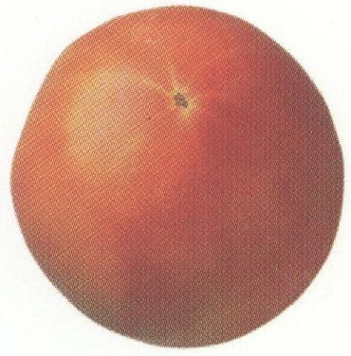
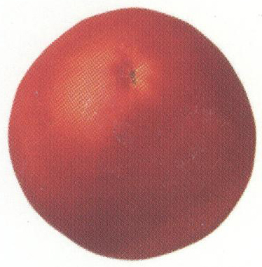
Stage 5 Light Red: Pinkish-red or red color shows on over 60%, but red color does not cover more than 90% of the tomato surface. Hold in dry storage, away from onions, and sort to pull out any tomatoes in stage 6. To speed ripening, trap ethylene gas released by tomatoes (see next section). Perfect for QSR tomato slicers.

Stage 6 Red: Red color shows on over 90% of the tomato surface. Perfect for slices and wedges, and ready to serve.

Fresh Fruit and Ethylene Gas
Virtually all fresh fruit, including tomatoes, produces a natural byproduct of the ripening process known as ethylene gas. Ethylene gas can be utilized to your advantage to hasten ripening. To speed ripening of fresh tomatoes at any stage, hold in a contained environment that traps the air around the tomatoes. For example, cover box holes with tape or place tomatoes in paper bags crimped at the top to seal in the air. Hold tomatoes in a warm area to increase ethylene activity. Add other fruits that release ethylene, such as bananas, avocados and other tree fruit to hasten ripening. Even simply covering a layer of tomatoes on a tray with towels can utilize the ethylene effect. It is important to note that some produce items, particularly leafy greens such as lettuces, are sensitive to ethylene gas and will turn brown if they come in close contact with it over a period of time. It is good practice to keep ethylene sensitive produce away from those items that release ethylene.

Ideal Conditions for the Foodservice Dry Storage Area
The dry storage area designated in a commercial kitchen is the place where non-refrigerated food items should be stored. By maintaining these ideal dry storage conditions, the quality of the food product will be maintained and preserved.

- Keep storerooms cool, dry and well ventilated. Moisture and heat are the biggest dangers to food items. The temperature of the storeroom should be between 55°F and 70°F (~ 12°C and 21°C). Keep relative humidity at 50% to 60%, if possible. A device which is used to measure humidity in a foodservice setting is called a hygrometer.
- Store food items away from walls and at least six inches off the floor.
- Keep food items out of direct sunlight.
- Keep the area clean and well maintained.
- Make sure that the area is well ventilated. This will help keep temperature and humidity constant throughout.
- Ideal temperature for holding Florida tomatoes is 55ºF to 60ºF (~ 12ºC to 15ºC) and 85% to 95% relative humidity.

PART III
PREP, COOKING METHODS AND RECIPE APPLICATIONS
Cutlery Tools
In large production kitchens, the garde manger department in a hotel or a high volume contract feeding venue, the consistency and ease of serrated knives for cutting many fruits including tomatoes is often preferred. Serrated knives are always ready for use and do not need to be sharpened. Tomato slicers are also a popular cutting choice, and yield a consistent, measured slice. Other chefs and cooks prefer to use a non-serrated knife, such as a chef’s knife, as they feel it provides for a more precise and exacting cut. The knife you choose is a matter of personal preference. It is important to remember, however, that a non-serrated knife must be kept sharp for working with tomatoes—a dull knife results in more injuries that a sharpened one.
Preparation Tips
Coring: Using a sharp paring knife make several angled cuts through the stem and under the core.
Seeding: Lay the tomato on its side and halve with a sharp serrated knife. Squeeze each half firmly enough to push out the seeds. Discard seeds.
Slicing: First core the tomato and lay it on its side. Using a sharp chef’s knife or a serrated knife, cut a very thin slice off each end and discard. Slice the tomato to desired thickness.
Peeling: To eliminate the skin in cooked dishes, gently lower 2 or 3 tomatoes at a time into enough boiling water to cover. Boil for 15 to 30 seconds, lift into a colander with a slotted spoon. Rinse briefly under cold running water, or shock in an ice water bath. Peel off and discard skins, or save for other use. The peeled and skinned tomato can then be diced (concasse) and used as a garnish or salad topping, or as a recipe ingredient.
Utilizing Skins: As an innovative and visually appealing garnish, cut and fry the skins to accent a plate presentation as you would with fried parsley, basil or spinach. Or, alternate colors with a variety of these flash-fried items. Another use is to dry and pulverize the skins and combine with a variety of salts for a unique flavor and cutting edge plating innovation.
Stuffing Shells: Lay the tomato on its side and, using a sharp chef’s knife or serrated knife, cut a very thin slice off the bottom. Slice off the top 1/4 of the tomato and discard. (The top minus the core may be chopped and added to the filling, or used in soups, stocks, etc.) Using a sharp paring knife and spoon, cut and scoop out the flesh, leaving slightly thick walls. Salt the cavities lightly and invert on a cooling rack for 15 minutes to drain.
Cooking Methods
Tomatoes are extremely versatile, whether used raw in salads, salsas, pestos, sandwiches, canapés, garnishes, marinades or dips, or cooked in stews, braises, sautés, or hot appetizers. Florida tomatoes can be pan fried, roasted, broiled, grilled and smoked. There are a large variety of recipes for traditional, contemporary and ethnic menu items or, use the ideas that follow to modify and modernize existing, classic preparations.
- To marinate, gently turn sliced, diced, wedged or chopped tomatoes in salad dressing or marinade. Let stand at room temperature 5 to15 minutes.
- To roast, arrange halved or sliced tomatoes in a single layer on a rack in a baking sheet. Lightly toss or brush with seasoned oil or salad dressing. Roast at 450°F until tomatoes soften and shrink, about 20-30 minutes.
- To broil or grill, preheat broiler or prepare grill. Cook tomato halves or slices until slightly charred, 8 to 10 minutes.
- To pan fry, heat ¼ cup olive or other vegetable oil in a medium skillet. Dip thick tomato slices in seasoned flour or cornmeal. Fry until golden brown, about 2 minutes on each side.
- To stuff, prepare tomato shells as previously directed. Fill with stuffing; place in a snug-fitting baking dish. Cover loosely with foil and bake at 375°F until tomatoes feel soft, about 25 minutes. Stuffed tomatoes can also be microwaved; 6 tomatoes will take about 5 minutes.
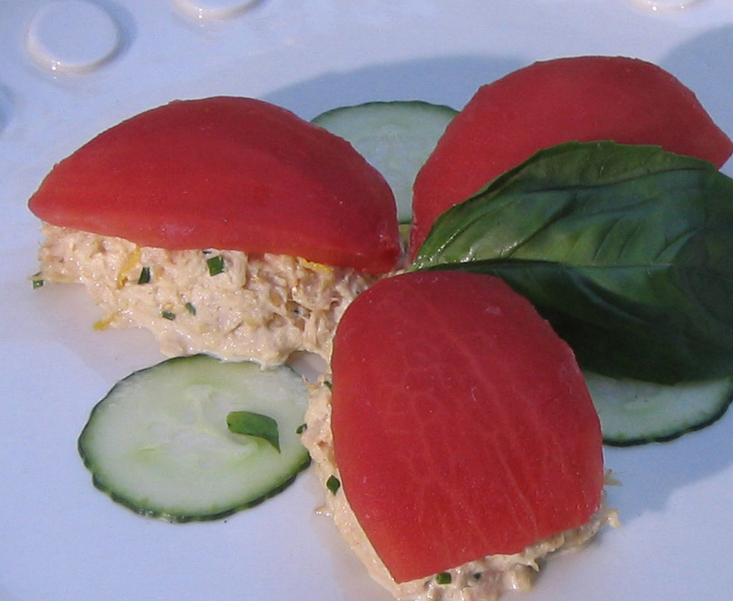
Contemporary Recipe Suggestions
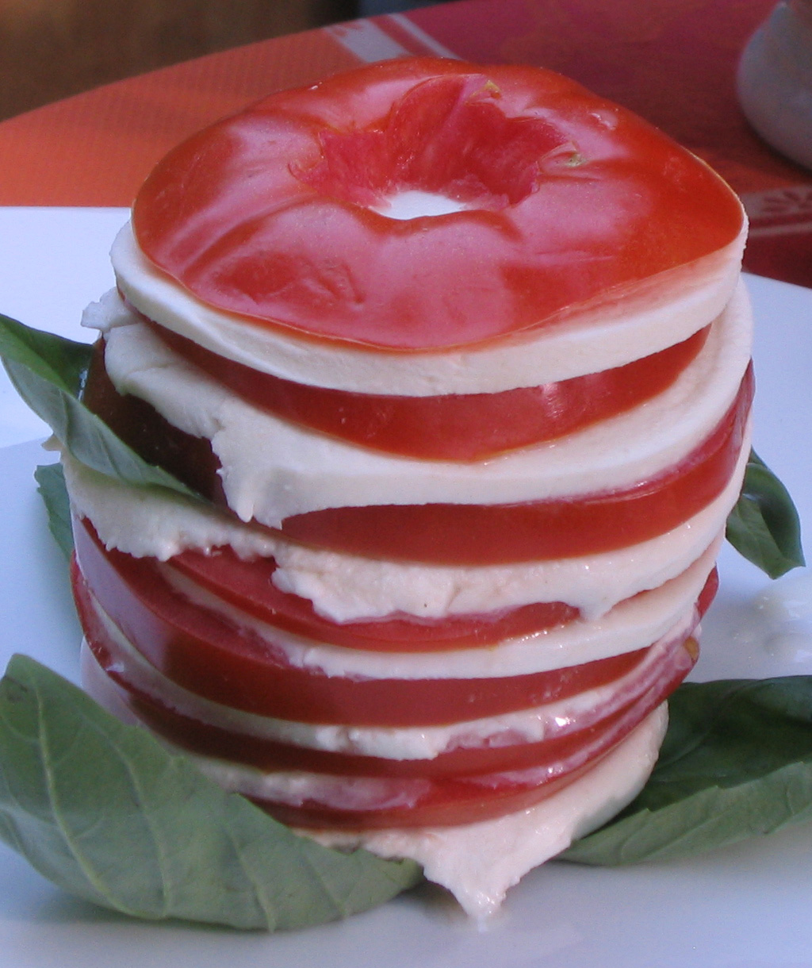
Tomato Sashimi: Blanch tomatoes, slice off ends, scoop out flesh and slice the shell in sections to resemble sashimi tuna pieces. Drape over scoops of tuna salad for a playful contemporary presentation.
Tomato Napoleons: Update the classic tomato, basil and mozzarella combination. Create a vertical salad by alternating thin slices of tomato and mozzarella on top of fresh basil leaves.
Tomato Tartar: Season chopped, seeded tomatoes with olive oil, lemon juice, capers, minced fresh basil, nicoise olives and onion. Serve on endive; use as a dip, or as a topping for crostini, steamed fish or baked potatoes.

BLT Pizza: Top pizza dough with thin slices of mozzarella and tomato, drizzled with olive oil. Crumble cooked bacon and fresh thyme over pizza and bake. Finish with a “nest” of thinly sliced arugula for a new presentation of a popular combination.
Spicy Tomato Chutney: The deep red color and bold flavor are a perfect accompaniment to a cheese plate. Make a paste of ground cumin, fennel and mustard seeds mixed with shallot, garlic, ginger and vinegar and heat in oil. Add blanched and seeded tomatoes and cook until thick.
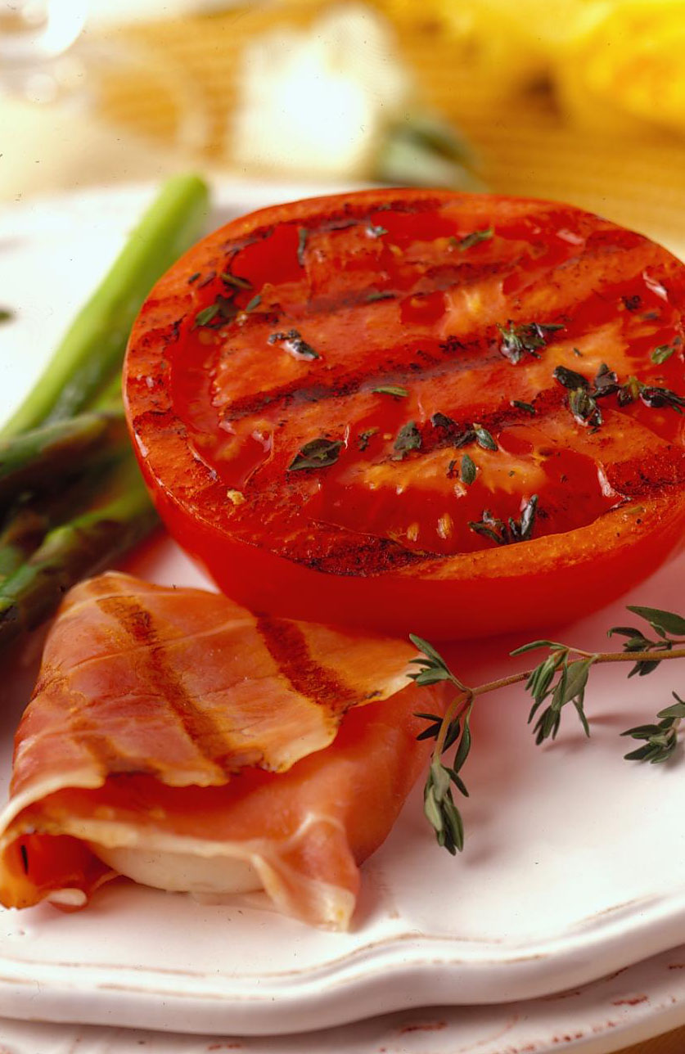
Upside-Down Tomato Cornbread: Line a buttered 9-inch cake pan with lightly seasoned tomato slices. Spoon cornbread batter over tomatoes and bake at 375ºF until the bread is baked, about 25 minutes.
Composed Spring Salad: Grill halved tomatoes, asparagus and goat cheese wrapped in a thin slice of Prosciutto. Arrange on a plate with pesto and a sprig of fresh rosemary.
Caribbean Jerk Tomato Salad: Lightly grill tomato wedges brushed with a mixture of oil and jerk seasoning; toss with sliced avocado, hearts of palm and chunks of cool, cooked chicken or pork.
Charred Tomatoes with Garlic and Olives: Broil whole tomatoes until slightly charred, about 10 minutes, turning once. Remove skins; chop flesh roughly. Transfer to a pan; add halved garlic cloves, olive oil and salt: roast at 400º F, until thickened and flecked with dark bits, about 1 hour. Serve drizzled with more olive oil and chopped ripe olives. Use as a dip for pita breads.
Thai Tomato Spring Rolls: Wrap a mixture of chopped tomatoes, mint, pork tenderloin, lemongrass and peanuts in wrappers. Serve with spicy soy dipping sauce.
Tomato Granita: Blend blanched and seeded tomatoes with honey, vinegar, salt and pepper and freeze. Serve with a basil-infused syrup for a refreshing intermezzo.
Tomato Goat Cheese Soufflés: Fill tomatoes with a basic soufflé mixture made with goat cheese and chives. Bake until puffy and golden brown.

PART IV
TOMATO PREFERENCES

Popularity of Tomatoes
Among vegetables, fresh tomatoes rank third in popularity with consumers, after potatoes and lettuce. Tomato consumption has increased by 50% over the past 40 years, and continues to climb. In 2007, U.S. per capita consumption reached a record 20.3 pounds per person, according to USDA’s Economic Research Service, and continues to be one of the world’s most popular produce items.

Consumer Preferences for Florida Tomatoes
After tasting Florida tomatoes side by side with Mexican-grown and hothouse varieties, two out of three participants in a taste panel of 1,200 consumers said that Florida tomatoes had the best flavor. Of those who preferred Florida tomatoes, 60 percent said that overall flavor was the reason for their choice. Others singled out “sweetness,” “texture” and “juiciness” as qualities they valued in the Florida fruit.

The independent study, conducted by Rose Research, Inc., in New York, confirmed an earlier series of flavor tests conducted over four years by the University of Florida and the U.S. Department of Agriculture.

In a subsequent survey, more than three-fourths of consumers surveyed indicated that they prefer USA-grown tomatoes over imports.

Foodservice Professional Preferences
Many foodservice professionals, particularly those highlighting locally produced or regional foods, find that incorporating Florida field-grown tomatoes into their dishes support their overall menu themes. The meaty texture and dense structure of Florida tomatoes makes them an ideal ingredient. Given their quest for maximizing flavor and texture chefs and cooks will likely find that using Florida field-grown vs. hot house tomatoes will enhance their dishes.

PART V
NUTRITION AND RESEARCH

Basic Tomato Nutrition
A medium tomato has only 25 calories, is high in vitamin C, a good source of vitamin A, low in sodium and fat, and cholesterol-free. Low fat diets rich in fruits and vegetables may reduce the risk of some types of cancer, a disease associated with many factors. Furthermore, vitamin A promotes good vision and helps to build and maintain healthy teeth and skin. Vitamin C plays an important role in maintaining body tissues and healing wounds and is also an antioxidant. Antioxidants help neutralize free radicals which are unstable molecules linked to the development of a number of diseases including cancer, cardiovascular disease and other age-related conditions such as Alzheimer's disease. In addition, Florida tomatoes contain lycopene, an antioxidant that gives tomatoes their rich, red color.
Tomatoes and Weight-Loss Diets
Fresh tomatoes add great color, flavor, variety and interest to menus making it easy to fit well into any restrictive or weight-loss diet. At only 5 grams of carbohydrate for one medium sized tomato, fresh tomatoes have a place in the South Beach Diet, Atkins Diet and other low-carbohydrate diets. Whereas some processed tomato products contain added sugars, such as the corn syrup often added to jarred marinara sauce, fresh tomatoes are a healthier ingredient choice, especially for diabetics. Tomatoes are also a healthier choice for those following a low fat or low cholesterol diet.

Tomatoes, Lycopene and Health
Lycopene entered the spotlight in 1995 with published studies from Harvard University identifying a positive association between intake of tomatoes and tomato-based foods and diminished risk of prostate cancer in a group of 48,000 health professionals followed over a six-year period. In a similar observational study in Italy, where tomatoes are a mainstay of the diet, it was found that tomatoes had been consumed in significantly lower quantities by a group of subjects suffering from colorectal and other digestive tract cancers than by the healthy control group.
Many more studies have been done examining the roles of tomatoes and lycopene in reducing the threat of other types of cancer (prostate, lungs, stomach) and chronic diseases affecting the lungs, heart and eyes. Early studies often focused on lycopene, a prominent antioxidant abundant in tomatoes. Lycopene may not be the whole story, though, according to Dr. Edward Giovannucci who concluded that “…the intake of tomatoes and tomato products lowers the risk of prostate cancer, especially the more aggressive forms. This benefit may be related to lycopene, but potentially beneficial substances instead of, or combined with lycopene cannot be excluded.” Another study supports the idea that tomatoes contain compounds that work independently of—or in concert with—lycopene. Researchers found that rats fed a powder made from whole tomatoes had significantly less prostate tumor growth than those given a lycopene supplement.
Unlocking Lycopene
While researchers continue to explore lycopene’s role in a healthy diet, there is general agreement that benefits are amplified by the interaction of a supporting cast of antioxidants and nutrients found in whole tomatoes. In addition to the importance of consuming lycopene through food, the effects can be enhanced further by heating tomatoes to make lycopene more available to the body. Consuming fresh tomatoes with fat lipids also improve the body’s ability to absorb the nutrients. Examples include roasting tomatoes with oil, or including some fat in a salad, with avocados, cheese or dressing.

PART V

Environmental and Food Safety Issues

Carbon Footprint Defined
In recent years, many chefs, culinary students, foodservice operators and consumers have become more aware and concerned with key issues affecting the environment, and specifically the food supply. The term “carbon footprint” is now applied to food as a measure of the impact its growth, harvest, transportation and even preparation have on the environment. Simply defined, a carbon footprint is a measure of the impact human activities have on the environment in terms of the amount of greenhouse gases produced, measured in units of carbon dioxide. It is a useful measurement for individuals and organizations to conceptualize their impact in contributing to global warming. A study carried out in 2006 at the Tara Garrett Center for Environmental Strategy at the University Of Surrey, England, demonstrated that hydroponic greenhouse tomatoes require more land and energy use to get the same output as field-grown tomatoes. The energy used in production can offset any energy savings in transportation or distance traveled when considering a food’s carbon footprint. An Ecological Footprint study in British Columbia found that for a greenhouse to produce 1000 tons of tomatoes, the environmental resources required are 14 to 21 times greater than for the same production from conventional field operations. In Europe, where the issue receives much greater attention, tests in the U.K. and Sweeden have both shown that field-grown tomatoes transported from Spain have less CO2 emissions by the time they reach the market than greenhouse tomatoes domestically grown.

Sustainable Foods
Another area of concern for consumers and operators is the inclusion of menu items which establish a collaborative effort to build more locally based, self-reliant food economies, also known as sustainable foods. This movement incorporates sustainable food production, processing, distribution and consumption, focusing on a preference to buy locally produced goods and services when available. Incorporating Florida field-grown tomatoes can play an important role in helping address the overall sustainability issue, while reducing reliance on tomatoes imported from other countries.

Food Safety
With outbreaks in recent years of salmonella in tomatoes and E. coli contamination found in spinach and lettuce, concern for the overall safety of other fruits and vegetables has raised justifiable concern. Given that both of the cases of E. coli contamination were linked to animal feces as well as irrigation waters, agriculture producers and packers have become keenly aware of these risk factors and endeavored to implement policies and procedures to greatly reduce the risk of contamination. Florida is the first state in the country to adopt a comprehensive food safety program with mandatory government inspection and audit of its tomatoes.

Producers and packers of Florida field-grown tomatoes have implemented key measures to continue to keep the supply safe and free of contamination. Specific measures include: strict animal control procedures, establishment of environmental and assessment records, and expanded internal audits. The protocols and record keeping of Florida’s tomato industry instill confidence by suppliers, operators and consumers in the safety of its food.

You can find much more on the topic of food safety, including the Tomato Best Practices Manual, by visiting http://www.floridatomatoes.org/food_safety.html.

Additional Resources, Recipes and References

Text References

Purchasing for Chefs: A Concise Guide, Feinstein and Stefanelli, Wiley

ServeSafe Essentials, National Restaurant Association Educational Foundation

On Cooking, A Textbook of Culinary Fundamentals, Labensky and Hause, Prentice Hall

Foods Around the World, A Cultural Perspective, Holly Heller, Prentice Hall

The Tomato In America, Andrew F. Smith, University of South Carolina Press

Internet Resources
www.floridatomatoes.org

www.floridatomatoes.org/links

